** **

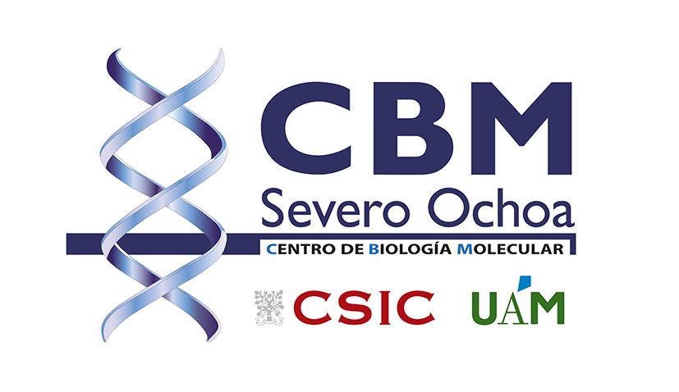

**JOB OFFER**

**Date: 05/09/2024**

**PRINCIPAL INVESTIGATOR:** Beatriz López Corcuera

**SCIENTIFIC PROGRAM:** Molecular Neuropathology

**JOB OFFER:** Postdoctoral Researcher CBM Call

**PROJECT TITLE:**

**Structure, function and regulation of GlyT2 variants associated to hyperekplexia.**

**PROJECT DESCRIPTION:**

Hyperekplexia (OMIM 149400) is a rare sensorimotor syndrome potentially lethal in newborns. It is caused by defects in the inhibitory glycinergic neurotransmission due to mutations in some human genes such as the neuronal glycine transporter GlyT2 (SLC6A5), responsible for supplying glycine to the presynaptic terminal. In this project, the pathogenic mechanisms of GlyT2 mutations found in hyperekplexia patients will be analyzed in terms of the structure of the transporter, its function, intracellular trafficking, interactome, regulation, as well as its consequences in embryonic or adult life. This study can guide future therapeutic approaches we wish to develop. http://www.cbm.uam.es/blopez

**LOCATION:**

Centro de Biología Molecular Severo Ochoa (CBM), Madrid, Spain, an international excellence research center offers a dynamic and collaborative environment and multidisciplinary training that brings together high-profile teams with complementary areas of expertise and with a common interest in translating basic research into knowledge for the clinic.

**CENTRO DE BIOLOGÍA MOLECULAR SEVERO OCHOA**

C/ Nicolás Cabrera, 1. CAMPUS UAM. 28049 MADRID

**ACADEMIC QUALIFICATION AND EXPERIENCE:**

* Highly motivated young candidates holding a PhD in Life Sciences obtained after 01/01/2019. Applicants who have completed their doctoral thesis defense but have not yet been awarded the degree are eligible to apply. They must have defended their thesis before signing the contract.
* At least one first author paper published in a well-recognized, peer-reviewed journal in the field. Preprints will be also considered.
* Recruited researchers must not have carried out their main research activity in Spain for more than 12 months in the 36 months immediately before the call deadline.
* Preference will be given to applicants with a background in neuroscience, neurotransmitter transport, cellular and molecular biology, confocal imaging and electrophysiological approaches. Fluency in English is mandatory.

**CONTACT:**

Candidates should send CV and motivation letter to: blopez@cbm.csic.es, before 09/15/2024.

**DEADLINE:**

09/30/2024

**OTHER INFORMATION:**

We are offering a postdoctoral position, with a duration of 3 years and an estimated gross salary of 40.500 €/year plus fringe benefits. To apply, candidates must submit a full application package via our website endorsed by a CBM IP: https://www.cbm.uam.es/en/home/jobs-at-the-cbmso